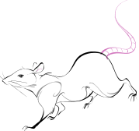
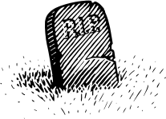
The BLACK DEATH

Day 3

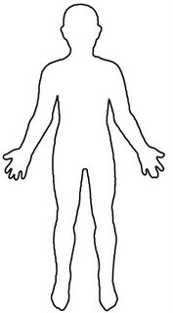
Day 1

Day 5

Day 2
DAY 4

How did people react?
People’s reactions depended on what they thought had caused the plague. There were 3 different ideas about this:
- That the plague was spread from person to person
- That the plague was caused by bad air
- That the plague was a punishment from God
Read the reactions in the table below. What might the people reacting like this have believed about the causes of the plague (you can tick more than 1)
 | Bad air | Person to person | Punishment by God
People say you should carry sweet smelling herbs
I have heard that you should burn the plague victims’ clothes
People are walking through the streets of London whipping themselves and praying
The Bishop of Winchester has run away
Some plague victims have been locked in their own homes
Rich people have left London to go to the country side where there is less infection

Creative task
Imagine that you run an Apothecary shop in London. In your book, design an advert for wealthy customers, advertising some of your remedies or prevention techniques.
Consider:
- What you know about real cures
- What people thought caused the plague
- What you know about the ingredients used in medieval medicine.

